**Week 2: GI/Fluoroscopy**

In week 2 you will review numerous Plain film KUB examinations both in interactive case file format and at the viewing station with the Resident, PA, and/or attending. This week is also focused on observing fluoroscopic procedures and You can work with the technologist to learn about patient positioning for several different abdominal examinations. Learning modules will include normal abdominal plain film anatomy as well as evaluating acute and not urgent findings in the abdomen and pelvis.

**Schedule**:

* Report to the GU/GI room daily at 8 am
* Inform the resident any scheduled lectures or meeting constraints.
* See what procedures are on the schedule to observe for the day am.
* Communicate with the technologist the exams you need to observe.
* Confirm the day and time you will be sharing your first PP presentation to Dr Finazzo/Dr Olinger as discussed, the first day on the block.

**Videos**:

The videos will review all the daily topics listed below. Review these videos/PDF material prior to the first day on service and review as needed throughout the week.

Day 1 Normal Anatomy  
Day 2 Calcifications   
Day 3 Bowel Pattern  
Day 4 Air Collections, Free Air  
Day 5 Lines and Devices

**KUB-Plain Film**

**Abdominal X-R**

Abdominal X-Ray: Introduction and Approach: <https://www.youtube.com/watch?v=SWd7onzmAPo>

KUB (13:15) <https://www.youtube.com/watch?v=xJR4guJ7kKw&t=320s>

KUB (19.0 min) <https://www.youtube.com/watch?v=_o5WFhvf9y4&t=242s>

KUB (1hr, 42 min) <https://www.youtube.com/watch?v=T0MrtewXiXE&t=3861s>

KUB (12:45) <https://www.youtube.com/watch?v=cml7KkkOVVw&t=328s>

Normal GI Tube Placement: [GI Tubes - YouTube](https://www.youtube.com/watch?v=r11f8eSIhQY&list=PLBkfUPj1TSRpkCVAo6w9PKfOlBSr35QJA&index=2)

lines and tubes KUB (10:56) <https://www.youtube.com/watch?v=zeQy3eM3LTQ&t=353s>

Bowel obstruction: <https://www.youtube.com/watch?v=jYYp5v0ndEY&t=2s>

Bowel obstruction: <https://www.youtube.com/watch?v=wmeZXlVObTw&t=19s>

Bowel Obstruction: <https://www.youtube.com/watch?v=33QsQbngCuk>

Foreign Body: <https://www.youtube.com/watch?v=gKj13Mq2FC8>

**Fluoroscopy**

**Video:** **Upper GI and Esophagus** [**https://www.youtube.com/watch?v=iXxqm0FfMio**](https://www.youtube.com/watch?v=iXxqm0FfMio)

**Post Op complication:** [**https://www.youtube.com/watch?v=71hob5INEh0**](https://www.youtube.com/watch?v=71hob5INEh0)

**DAY 1 ANATOMY AND CALCIFICATIONS:**

Review the videos provided above PRIOR to arriving to the department. No additional videos will be provided this week. Each day there will be a different area in the abdomen to focus on. Review the Days cases prior to arrival to the department and spend the day directly with the resident and PA (Keep in mind that you will be seeing all types of cases at the reading station. But try to pay close attention to the daily topics assigned and please review each day’s cases prior to arrival.)

If you still feel unsure of your basic skill set after completing the first day on site, then then please follow this additional link and take the Quiz at the end of the presentation.

<https://nle.nottingham.ac.uk/websites/abdominal_radiology/home.html>

**PART 1: INTERACTIVE CASE FILES**

On your first day pick 2 or 3 cases from the normal anatomy cases files; discuss and identify the following structures on at least 2 different patients.

Liver/ hepatic angle  
Spleen/splenic angle  
Gas and stool in the colon  
Gastric Air  
Outline both kidneys upper and lower ole  
Preperitoneal fat.   
Quadratus lumborum muscle  
Psoas Muscles  
Obturator Internum muscles  
Sacrum  
Bladder  
Diaphragm  
Costophrenic angles  
Heart  
Spine Numbering

**PART 2: TEST YOUR KNOWLEDGE**

Answer the following below to discuss with radiology staff as time permits. Submit the completed form to [pina_finazzo@med.unc.edu](mailto:pina_finazzo@med.unc.edu) when completed.

**GENERAL KNOWLEDGE**:

1. What does KUB stand for? What is the standard view
2. What is included in an acute abdominal series
3. What has the lowest density on a KUB. Provide an example
4. What has the highest density on a KUB. Provide an example
5. Why do we do cross-table lateral projection with the right side elevated?
6. how much air is needed to be identified on plain films? .

**SOFT TISSUES:**

1. What is the normal size of the liver and spleen? How do you measure size?
2. How will the right and left colon be displaced in the setting of hepatomegaly and splenomegaly respectively.
3. Where is the general location of the pancreas
4. Where would you expect to find a horseshoe kidney

**FAT SHADOW**

1. What can cause widening of the distance between the properitoneal fat and ascending or descending colon
2. What should you think if you see convexity of the psoas muscle contour

**GAS PATTERNS**

1. What can cause air fluid levels in the small bowel
2. What is the difference between small and large bowel folds.
3. How is the jejunum different than the ileum?
4. Where is you search pattern to identify extra luminal gas (example: retro peritoneum). List at least 4 sites.
5. What would be a cause of a bowel gas pattern on the right or left below the level of the bony pelvis.

**BONES AND CALCIFICATONS**

Calcifications in the abdomen include calcified arteries, calculi in the urinary or biliary tract, prostatic calculi, pancreatic calcifications (which are usually indicative of chronic pancreatitis, with or without carcinoma), appendicolith, or ectopic gallstone in the small bowel associated with mechanical obstruction from gallstone ileus. Some foreign bodies, including ingested foreign bodies, bullets, or surgical clips, may be seen in the abdomen. Other rare structures, such as parasitic, metastatic, or heterotopic bone formations, also may be seen in the abdomen.

*Gallstone*: About 15% to 20% of gallstones are calcified sufficiently to be seen on plain abdominal film. Most gallstones comprise mixed components, including cholesterol, bile salts, and biliary pigments. Pure cholesterol and pure pigment stones are uncommon. Calcified gallstones vary in size and shape. Most gallstones have thin, marginal calcification with central lucency and are laminated, faceted, or irregular in shape. Some gallstones contain gas in their fissures, whether calcified or noncalcified. Milk-of-calcium or “limy” bile occurs in patients with long-standing cystic duct obstruction. The bile contains a high concentration of calcium carbonate and is densely radiopaque on plain radiograph Calcification of the gallbladder wall (porcelain gallbladder) develops in patients with chronic cholecystitis, cholelithiasis, and cystic duct obstruction. Porcelain gallbladder is characterized by curvilinear calcification in the muscular layer of the gallbladder mimicking a calcified cyst. In general, ultrasonography is the primary modality now used to evaluate the gallbladder but be aware of different appearance of gallstones and their location based on supine vs upright films.

*Nephrolithiasis:* Nephrolithiasis is the most common cause of calcification within the kidneys and form with any process that creates urinary tract stasis. Most renal calculi (85%) contain calcium complexed with oxalate and phosphate salts.

1. Most renal calculi contain calcium. What are the other 3 other renal stone composition.
2. CT is more sensitive than plain radiography in evaluating urinary calculi. All renal stones are hyperdense/visible on CT despite its composition. Which renal calculi are lucent/not visible on x ray?
3. What is a staghorn calculus?

*Adrenal*: Adrenal gland and calcifications: The right gland is lower than the left. Normally the adrenal gland measures less than 2.5 × 3 cm. Stippled, mottled, discrete, or homogeneous calcifications may appear as a portion of the adrenal gland or may occupy the entire organ, forming a triangular clump in the adrenal glands. Most adrenal calcifications are incidental findings in normal-sized glands. They are caused by neonatal adrenal hemorrhage, prolonged hypoxia, severe neonatal infection, or birth trauma. Less than one-fourth of patients with Addison’s disease have adrenal calcifications.

**SO** **WHO IS AUNT MINNIE? NAME THE CALCIFICATIONS IN THE ATTATCHED CASES:**

Case 1  
.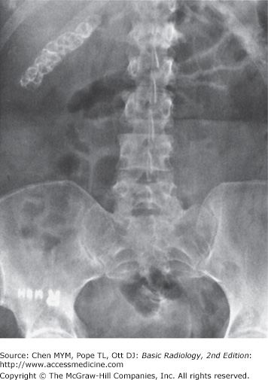   
Patient with intermittent pain. What is the most likely diagnosis?

1. Adrenal calcification
2. Calcified gallstones
3. Kidney stones
4. Milk-of-calcium bile in the gallbladder

Case 2  
 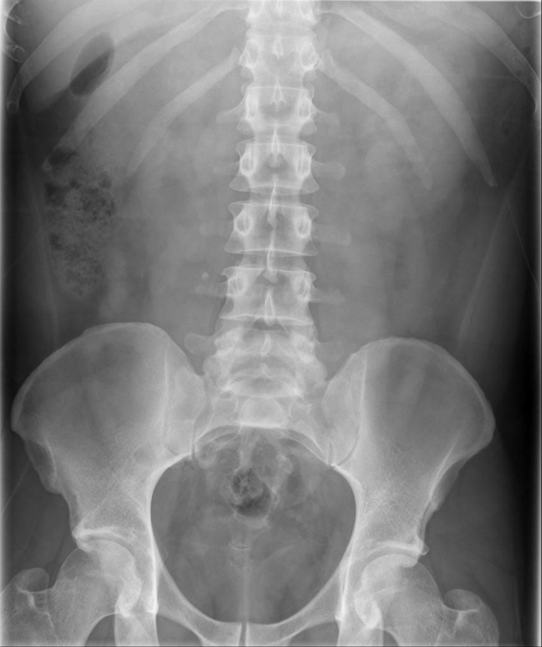  
Patient with intermittent right side pain. What is the most likely diagnosis:

1. Adrenal calcification
2. Calcified gallstones
3. Kidney stones
4. Milk-of-calcium bile in the gallbladder

Case 3  
 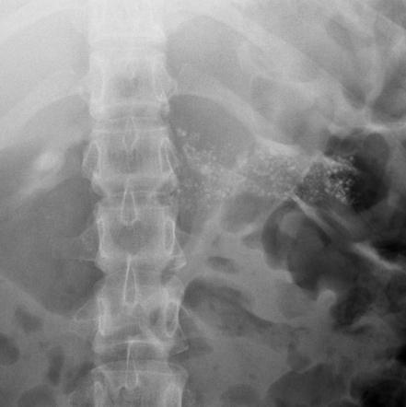

Male with ETOH use and abdominal pain. What is the most likely diagnosis?

1. Adrenal calcification.
2. Calcified hepatic metastases.
3. Pancreatic calcification.
4. Primary calcified mucoproducing adenocarcinoma in the colon.

Case 4  
 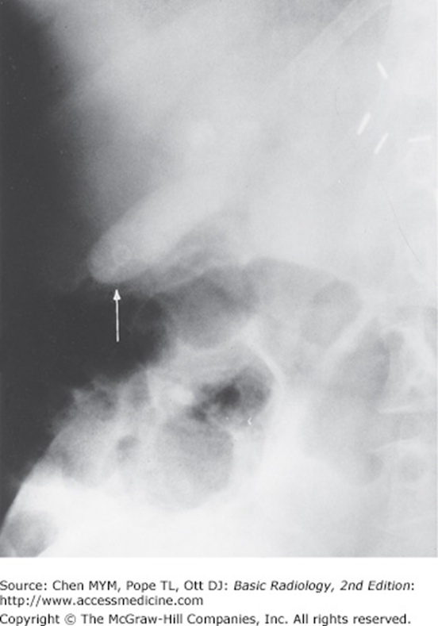

Milk-of-calcium bile. Is this a supine or upright image? How would the gallbladder position change in the other view.

Case 5  
 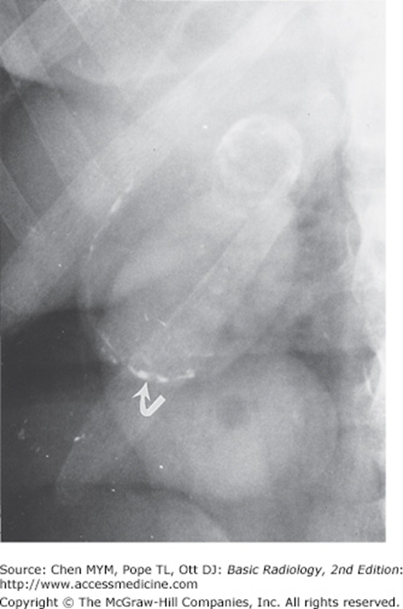

Where are these calcifications located? What is the primary diagnosis of these curvilinear discontinuous calcifications?

Case 6  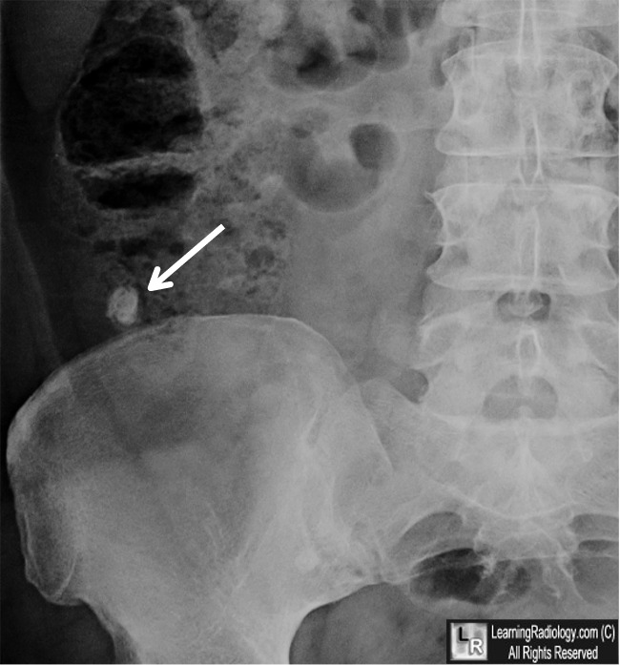

A 15-year-old boy presents with right lower quadrant pain and fever. What is the most likely diagnosis:

1. Appendicolith
2. Ectopic gallstone
3. Pelvic phlebolith
4. Right ureteral calculus

Case 7 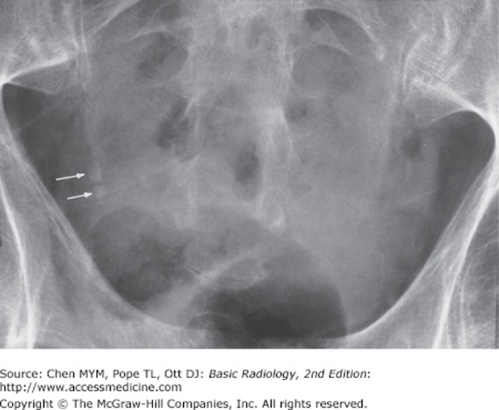

A 64-year-old man presents with hematuria. What is the most likely diagnosis:  
A. Calcified ovarian tumor  
B. Multiple phleboliths  
C. Multiple ureteral calculi  
D. Uterine fibroid calcification

Case 8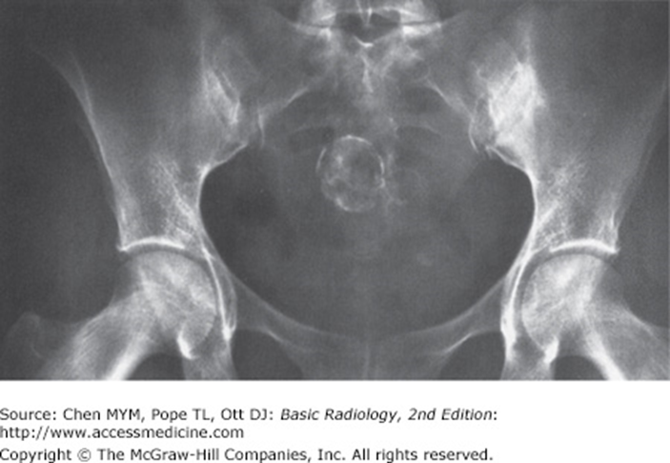

A 48-year-old woman presents with lower abdominal fullness. What is the most likely diagnosis?

1. Bladder calculus
2. Chondrosarcoma of the sacrum
3. Cystadenoma of the ovary
4. Uterine fibroid calcifications

Case 9: 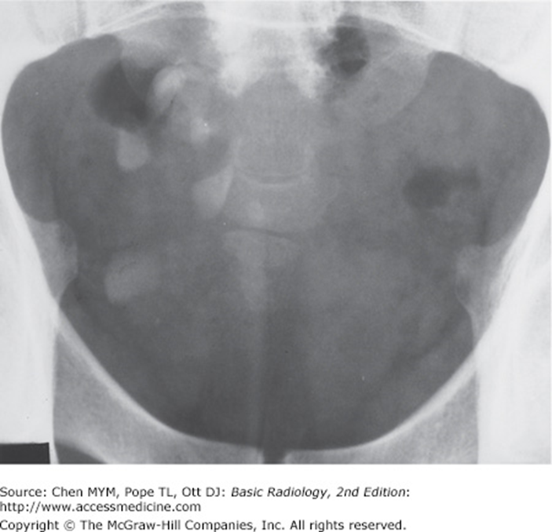

A 14-year-old girl presents with lower abdominal pain and a palpable mass in the pelvis. What is the most likely diagnosis?

1. Bladder calculi
2. Calcified vas deferens
3. Ovarian dermoid cyst
4. Uterine fibroid calcification

Case 10: 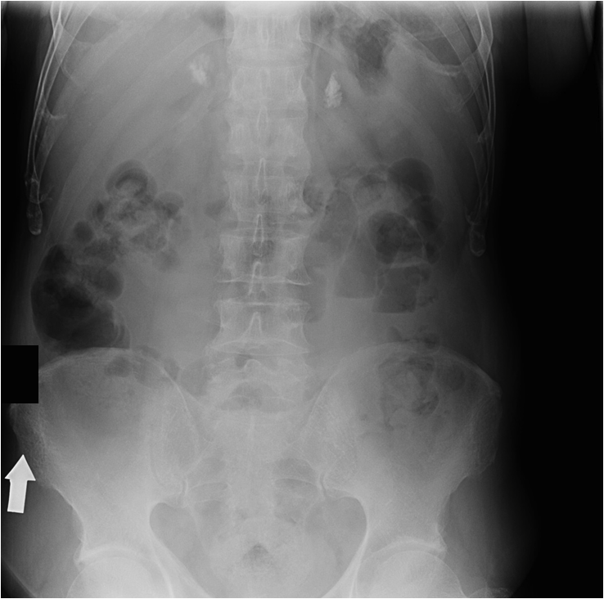 Solid adrenal calcifications. an asymptomatic patient with a history of complicated childbirth. Where are these calcifications located?

1. Kidneys
2. Pancreas
3. Duodenum
4. Adrenals

Case 11 Patient A  
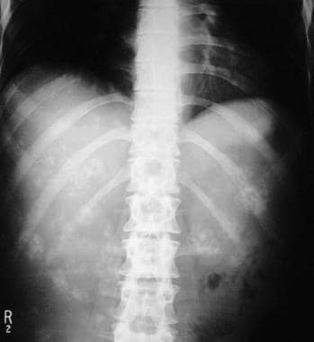   
Case 11 Patient B  
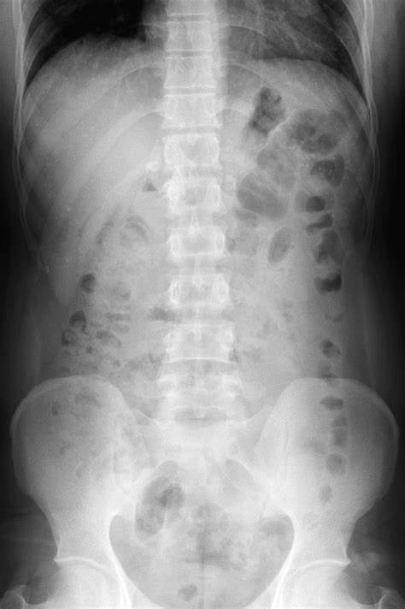

Two patients with hepatic calcifications. Which patterns favors mucin producing colorectal metastasis? Which favors post infectious granulomas? Name few infections that can lead to granulomas in spleen and liver. Name few primary cancers that may cause calcified hepatic or peritoneal metastasis.

Case 12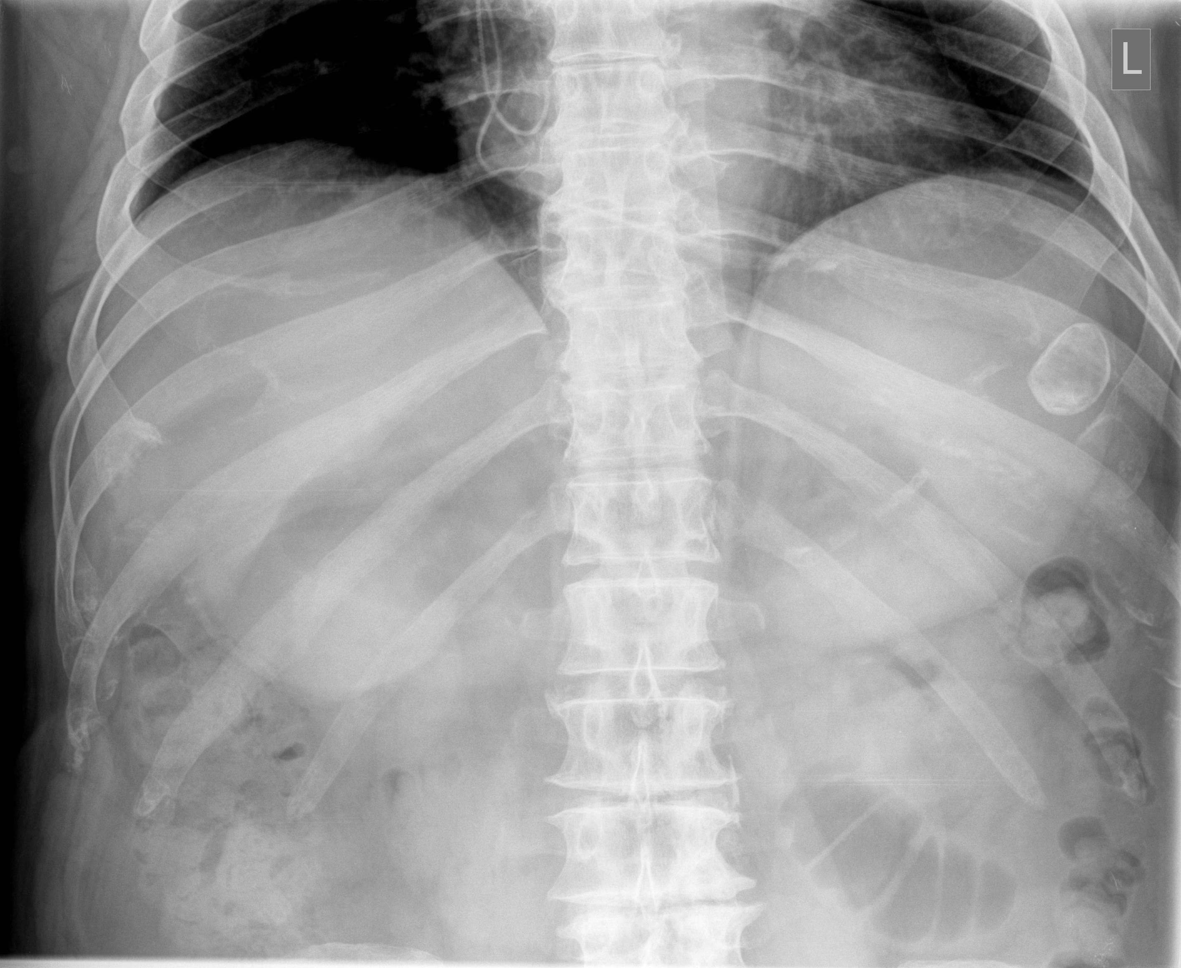

What is the most likely etiology of the splenic calcification?

Case 13: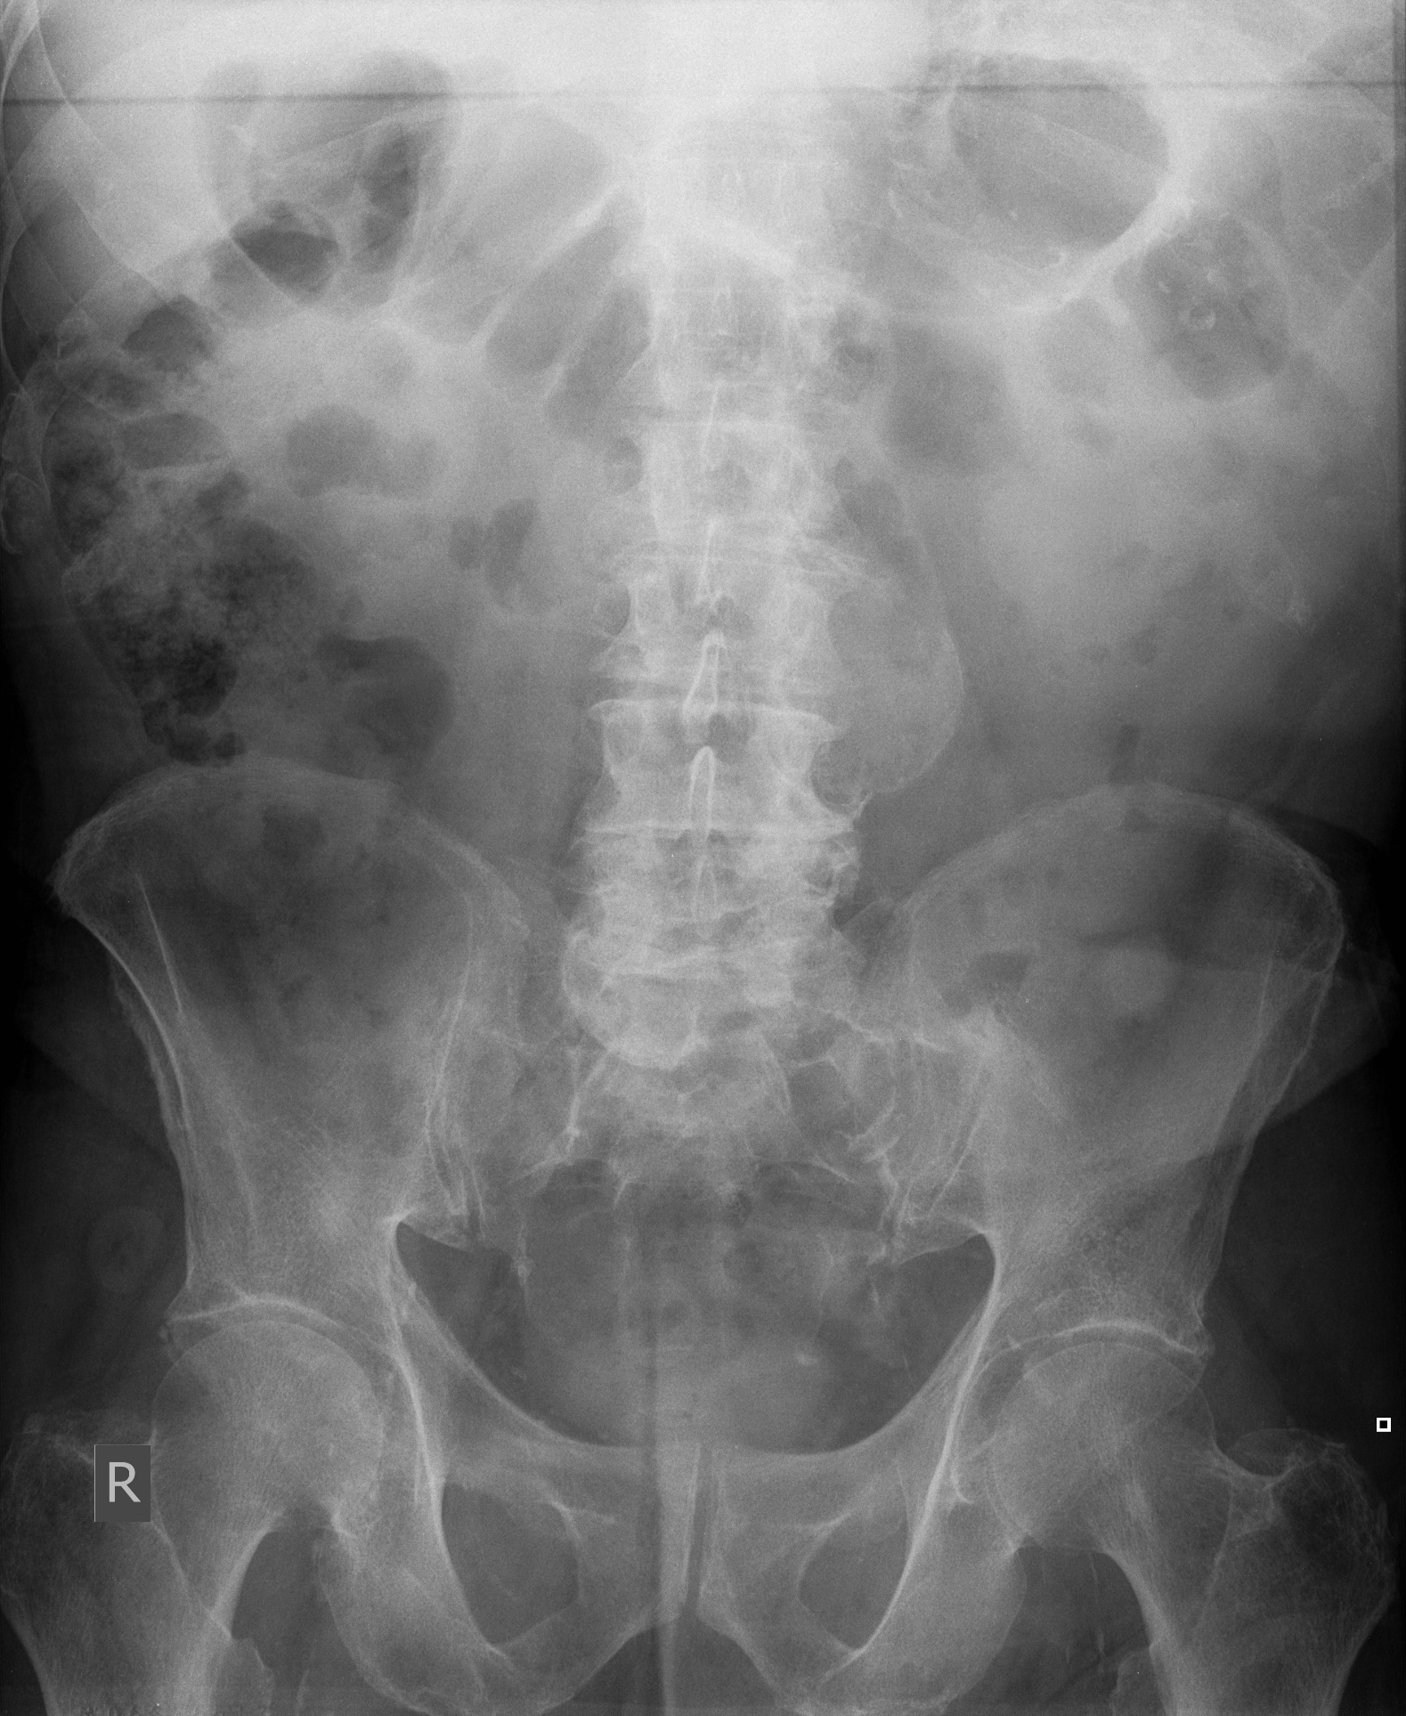

Patient with acute back pain. What is the critical finding?

Case 14:

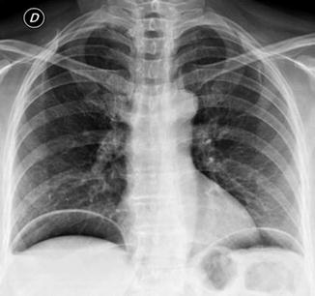 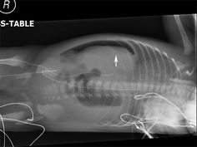

How much air is needed to be detected by radiography?

PART 3: REVIEW OF DOWNLOADED INTERACTIVE CASE FILES ON CALCIFICATIONS (as time permits)

PART 4: ATTEND ANY SPECIAL PROCEDURES SCHEDULED

PART 5: WATCH AND REVIEW ADDITIONAL CASE AS PERFORMED AT THE READING STATION

PART 6: OBSERVE TECHNOLOGIST PERFOMING ABDOMINAL IMAGING EXAMINATIONS ON OUTPATIENTS AND AT BED SIDE ON HOSPITAL FLOORS

**FEW BASICS FOR FLUROSCOPY**

**Esophagus**: The vestibule separates the A Ring (above) and B Ring (Below). Learn how to demarcate the vestibule and know what is Schatzki ring means. Answer: symptomatic dysphagia is when B ring narrowed <13 mm

What is Barretts esophagus, common reason it develops, where is it located, what histologic subtype of cancer. Answer: High stricture and HH, precurser to adenoCA from reflux in distal esophagus

What location is typical for squamous cancer and what is the cause lye injestion, tobacco mid esophagus

What is most common mucosal lesion of the esophagus : (papilloma—hyperplastic squamous epithelium)

What are the 2 types of Hiatal hernias? Sliding (type 1) and Para-esophagesl (type 2)

What is ***fundoplication***. What are the 2 main indications for this procedure. What does ***Nissen vs Loose*** (fundoplication mean?) . ***Trivia***: Early complication is obstruction due to post op edema or wrap too tight. Late complication (failure) is recurrent HH or reflux. The most commonly cause for recurrent reflux is due to a slipped Nissen—typically related to “short esophagus” and is treated with ***Collis Gastroplasty***. How can you tell Nissen has slipped?

Gastric fundus wrapped around lower end of esophagus and stitched to reinforce the LES. Nissen 360 wrap or Loose <360 “toupet” Slipped is if the wrap of the narrowed esophagus exceeds >2cm.

***Esophageal Ulcers***: Herpes has Halo where CMV and HIV have large flat ulcers. Look for case while on service.

***Varicies***: What is the difference between uphill and downhill varices. Uphill Portal hypertension, Downhill sup venacava obstruction.

**Esophageal diverticulum:**

**NAME LOCATION CAUSE**

Zenker Pulsion posterior Killian Dehisence

Killiam-Jamieson Pulsion anterior and lateral weakness of cricopharyngeus muscle

Traction Mid Esophageal Assoc with scaring/granulomatous/TB

Epiphrenic Pulsion “Right” diaphragm level Associated with motor abnormality

Pseudodiverticulosis multiple small Chronic reflux

**Dilated Esophagus**: What is the difference between

Achalasia : Motor disorder 2/3 esophagus with absent peristatlsis and LES wont relax _Birds Beak.

Scleroderma. Scleroderma the LES is incompetent and leads to chronic relfus, barrets, NSIP

**Stomach:**

H Pylori Antrum

Ulcers from aspirin Multiple ulcers in stomach not in duodenum  
ZE Gastrinoma most common is multiple ulcer is in Duodenal bulb.   
Menetrier’s Fundus, spares the antrum can be caused by HPylori or HCMV

Lymphoma Will cross the pylorus as does adenocarcinoma.

Selective Polyposis:  
Gardners—FAP—Desmoids, papillary thyroid ca  
Lynch Syndrome: Hereditary non polyposis syndrome—DNA mismatch get cancer everywhere  
Peutz-Jeghers—small and lg bowel, pancreatic and GYN cancers  
Cowdens—thyroid cancer  
   
**Exams to observe with the technologist and minimum cases to see:**Bedside KUB for tube placement (3) __________________, __________________,_________________  
Standard KUB (3) __________________________, _______________________, ___________________  
Supine and Upright Abdomen (2) _________________________,______________________  
Decubitus (1) __________________________  
Abdomen with chest (2) ______________________, _________________________

**Fluoroscopic Procedures observed: Please List:**

**INTERACTIVE CASE FILES**

**Lines Tubes and Stents**

AICD/PACER

14 AO stent

biliary stent and pigtail cath

cysto-esophageal stent

24 ECMO/LVAD

2 EKG leads

enterostomy

external lines

7 weighted gastrojejunostomy tube

22, 3g-tube

18 IVC filter

J-stent kidney

lap band

23 lung drain

medaport

5 non-weighted enteric tube

pancreatic stent

peritoneal drain peritoneal drain

POEM (achalasia)

renal artery stent

1 sacral nerve stimulator

sitz

surgical clips

surgical drains

trans gastric stent

transplant ureteral stent

20 urethral /foley temp catheter

vac sponge

12weighted ng

**Surgeries**

Cholecystectomy

external (burn pt)

RLQ transplant

mesh hernia repair

right colon

**Bowel**

small bowel

lg bowel ileus/Lg stool burden

large bowel

distended stomach