**US DAY 1: THYROID ULTRASOUND SCANNING, CHARACTERIZING AND BIOPSY**

**INTRODUCTION**

In this lesson, we provide a complete series of sonographic images and videos to illustrate benign and malignant features of thyroid nodules according to the TI-RADS classification. The aim is for the participant to independently evaluate US examinations and classify the identified nodules as benign, suspicious, or malignant using the TI-RADS system, and for planning for further investigations. In addition, the participant will observe Thyroid biopsy under US guidance and learn the cytologic findings that meet appropriate specimen sample for final diagnosis.

* Video Lectures:
  + [(434) How to scan Thyroid gland by Ultrasound - YouTube](https://www.youtube.com/watch?v=3LZlNOJs0Hg)
  + [(434) Basics of Thyroid Ultrasound - YouTube](https://www.youtube.com/watch?v=iTK148HZjIc)
  + [(434) Thyroid Nodules Sonographic Evaluation and Biopsy Recommendations - YouTube](https://www.youtube.com/watch?v=6EqqWYYbl48)
  + [(434) Thyroid Nodules - YouTube](https://www.youtube.com/watch?v=IjBAbIyvPiw)
  + [Thyroid Nodules](https://www.youtube.com/watch?v=DH1FZdPtO6c)
  + [Diffuse Thyroid Disease](https://www.youtube.com/channel/UCauGkRvu7_p0obZ8Yp0bpMw)
  + [Deb Baumgarten](https://www.youtube.com/watch?v=t9aEMNRo-Gs)

**ASSIGNMENT DAY 1**

Please observe live thyroid scan and meet with the technologist prior to sitting with resident/attending.

At the completion of the day the MS should be able to answer the following questions:

* 1. What structures are included in a standard order for US Neck?
  2. What frequency transducer is best for scanning small parts? Higher or lower frequency
  3. What are the pre biopsy instructions for the patient (ex pre bx labs? Fasting? Med? Etc)?
  4. What are the potential biopsy complications?
  5. What are the post biopsy instructions given to the patient?
  6. What is the cytopathologist looking for to confirm adequate sample?
  7. When is thyroid Uptake and Scan Scintigraphy useful in the management of thyroid disease?

**Thyroid Live Scanning:** Patient: (initials and last 4 UN numbers only) _____________

Tech Initials ___________

**Observe at least one live scan and review 2 patients.** If there are no scheduled thyroid patients in the morning, pick two patients from the list that are pending review by the Attending. Attempt to characterize the largest 1 or 2 lesion(s) only.

**Thyroid Biopsy**: Patient: (initials and last 4 UN numbers only) ___________

Tech Initials ________

Specimen contained adequate: ___________________________ per high power field for interpretation.

Please add additional features that the path tec looks for adequacy of the biopsy specimen and the different solutions he uses for staining and its purpose: ______________________________________________________________________________

Please list: Thyroid biopsy preparation; post bx instructions and potential biopsy complications: ____________________________________________________________________________________________________________________________________________________________

**Thyroid Nodule Characterization**

* (For purpose of this exercise---if multiple nodules are present then characterize the single largest nodules that measure > 1cm in size). Larger rendered images available in the US rad reading room.

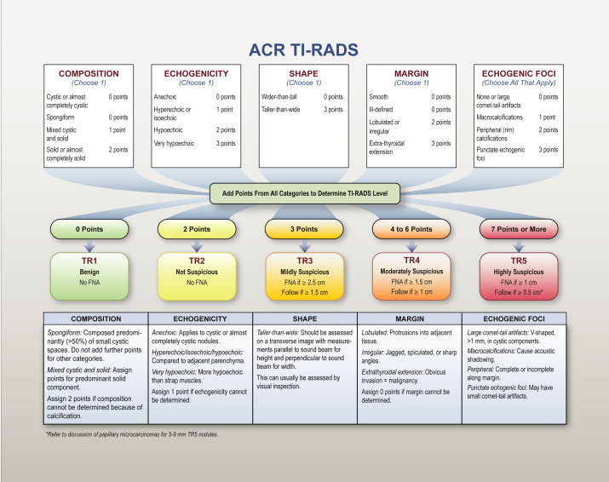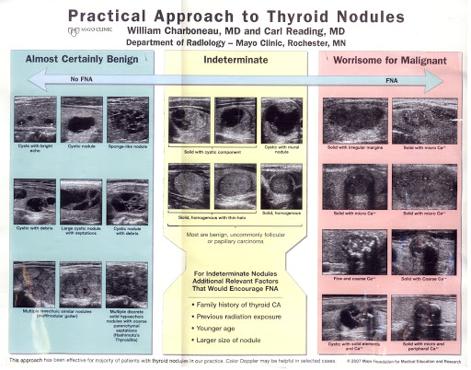

**Interactive Teaching File Cases (1-5)**

**Case 1: Nodule: 1 (characterize the largest nodule only)**  
Size: _____________________ cm  
Location: Left/Rt Upper/Mid/Lower  
Composition: __________________ (___points)  
Echogenicity: Iso/Hyper/Hypoechoic (___points)  
Shape: Not taller than wide/ taller than wide ( (___points)  
Margin: lobulated/irregular (___points)  
Echogenic foci: _________________ (_____points)  
  
ACR TI-RADS total points: _______  
ACR TI-RADS risk category: TI-RADS _______  
ACR TI-RADS Recommendation: _____________________________________________

_____________________________  
TI-RADS 1 (0 points): Benign- No FNA indication  
TI-RADS 2 (2 points): Not suspicious- No FNA indicated  
TI-RADS 3 (3 points): Mildly suspicious- FNA is > or = 2.5 cm, follow if > or = 1.5 cm  
TI-RADS 4 (4-6 points): Moderately suspicious- FNA if > or = 1.5 or follow if > or = 1.0 cm  
TI-RADS 5 (7 or more points): Highly suspicious- FNA if >=1.0 cm, follow if >=0.5 cm  
NOTE: The TI-RADS classification of thyroid nodules has been adopted to standardize risk stratification based on a common lexicon to inform practitioners about which nodules warrant biopsy. The imaging criteria for TI-RADS criteria and documentation are available online at www.acr.org/Quality-Safety/Resources/TIRADS

**Case 2: Nodule: 1 (characterize the largest nodule only)**  
Size: _____________________ cm  
Location: Left/Rt Upper/Mid/Lower  
Composition: __________________ (___points)  
Echogenicity: Iso/Hyper/Hypoechoic (___points)  
Shape: Not taller than wide/ taller than wide ( (___points)  
Margin: lobulated/irregular (___points)  
Echogenic foci: _________________ (_____points)  
  
ACR TI-RADS total points: _______  
ACR TI-RADS risk category: TI-RADS _______  
ACR TI-RADS Recommendation: _____________________________________________

_____________________________  
TI-RADS 1 (0 points): Benign- No FNA indication  
TI-RADS 2 (2 points): Not suspicious- No FNA indicated  
TI-RADS 3 (3 points): Mildly suspicious- FNA is > or = 2.5 cm, follow if > or = 1.5 cm  
TI-RADS 4 (4-6 points): Moderately suspicious- FNA if > or = 1.5 or follow if > or = 1.0 cm  
TI-RADS 5 (7 or more points): Highly suspicious- FNA if >=1.0 cm, follow if >=0.5 cm  
NOTE: The TI-RADS classification of thyroid nodules has been adopted to standardize risk stratification based on a common lexicon to inform practitioners about which nodules warrant biopsy. The imaging criteria for TI-RADS criteria and documentation are available online at [www.acr.org/Quality-Safety/Resources/TIRADS](http://www.acr.org/Quality-Safety/Resources/TIRADS)

**Case 3: Nodule: 1 (characterize the largest nodule only)**  
Size: _____________________ cm  
Location: Left/Rt Upper/Mid/Lower  
Composition: __________________ (___points)  
Echogenicity: Iso/Hyper/Hypoechoic (___points)  
Shape: Not taller than wide/ taller than wide ( (___points)  
Margin: lobulated/irregular (___points)  
Echogenic foci: _________________ (_____points)  
  
ACR TI-RADS total points: _______  
ACR TI-RADS risk category: TI-RADS _______  
ACR TI-RADS Recommendation: _____________________________________________

_____________________________  
TI-RADS 1 (0 points): Benign- No FNA indication  
TI-RADS 2 (2 points): Not suspicious- No FNA indicated  
TI-RADS 3 (3 points): Mildly suspicious- FNA is > or = 2.5 cm, follow if > or = 1.5 cm  
TI-RADS 4 (4-6 points): Moderately suspicious- FNA if > or = 1.5 or follow if > or = 1.0 cm  
TI-RADS 5 (7 or more points): Highly suspicious- FNA if >=1.0 cm, follow if >=0.5 cm  
NOTE: The TI-RADS classification of thyroid nodules has been adopted to standardize risk stratification based on a common lexicon to inform practitioners about which nodules warrant biopsy. The imaging criteria for TI-RADS criteria and documentation are available online at [www.acr.org/Quality-Safety/Resources/TIRADS](http://www.acr.org/Quality-Safety/Resources/TIRADS)

**Case 4: Nodule: 1 (characterize the largest nodule only)**  
Size: _____________________ cm  
Location: Left/Rt Upper/Mid/Lower  
Composition: __________________ (___points)  
Echogenicity: Iso/Hyper/Hypoechoic (___points)  
Shape: Not taller than wide/ taller than wide ( (___points)  
Margin: lobulated/irregular (___points)  
Echogenic foci: _________________ (_____points)  
  
ACR TI-RADS total points: _______  
ACR TI-RADS risk category: TI-RADS _______  
ACR TI-RADS Recommendation: _____________________________________________

_____________________________  
TI-RADS 1 (0 points): Benign- No FNA indication  
TI-RADS 2 (2 points): Not suspicious- No FNA indicated  
TI-RADS 3 (3 points): Mildly suspicious- FNA is > or = 2.5 cm, follow if > or = 1.5 cm  
TI-RADS 4 (4-6 points): Moderately suspicious- FNA if > or = 1.5 or follow if > or = 1.0 cm  
TI-RADS 5 (7 or more points): Highly suspicious- FNA if >=1.0 cm, follow if >=0.5 cm  
NOTE: The TI-RADS classification of thyroid nodules has been adopted to standardize risk stratification based on a common lexicon to inform practitioners about which nodules warrant biopsy. The imaging criteria for TI-RADS criteria and documentation are available online at [www.acr.org/Quality-Safety/Resources/TIRADS](http://www.acr.org/Quality-Safety/Resources/TIRADS)

**Case 5: Nodule: 1 (characterize the largest nodule only)**  
Size: _____________________ cm  
Location: Left/Rt Upper/Mid/Lower  
Composition: __________________ (___points)  
Echogenicity: Iso/Hyper/Hypoechoic (___points)  
Shape: Not taller than wide/ taller than wide ( (___points)  
Margin: lobulated/irregular (___points)  
Echogenic foci: _________________ (_____points)  
  
ACR TI-RADS total points: _______  
ACR TI-RADS risk category: TI-RADS _______  
ACR TI-RADS Recommendation: _____________________________________________

_____________________________  
TI-RADS 1 (0 points): Benign- No FNA indication  
TI-RADS 2 (2 points): Not suspicious- No FNA indicated  
TI-RADS 3 (3 points): Mildly suspicious- FNA is > or = 2.5 cm, follow if > or = 1.5 cm  
TI-RADS 4 (4-6 points): Moderately suspicious- FNA if > or = 1.5 or follow if > or = 1.0 cm  
TI-RADS 5 (7 or more points): Highly suspicious- FNA if >=1.0 cm, follow if >=0.5 cm  
NOTE: The TI-RADS classification of thyroid nodules has been adopted to standardize risk stratification based on a common lexicon to inform practitioners about which nodules warrant biopsy. The imaging criteria for TI-RADS criteria and documentation are available online at [www.acr.org/Quality-Safety/Resources/TIRADS](http://www.acr.org/Quality-Safety/Resources/TIRADS)

**Live Cases**

**Case 1: (initials and last 4 UN numbers only)__________Rad Review:_________________**

**Nodule: 1 Thyroid echotexture**: homogenous or heterogenous  
Size: _____________________ cm  
Location: Left/Rt Upper/Mid/Lower  
Composition: __________________ (___points)  
Echogenicity: Iso/Hyper/Hypoechoic (___points)  
Shape: Not taller than wide/ taller than wide ( (___points)  
Margin: lobulated/irregular (___points)  
Echogenic foci: _________________ (_____points)

ACR TI-RADS total points: _______  
ACR TI-RADS risk category: TI-RADS _______  
ACR TI-RADS Recommendation: ______________________________  
TI-RADS 1 (0 points): Benign- No FNA indication  
TI-RADS 2 (2 points): Not suspicious- No FNA indicated  
TI-RADS 3 (3 points): Mildly suspicious- FNA is > or = 2.5 cm, follow if > or = 1.5 cm  
TI-RADS 4 (4-6 points): Moderately suspicious- FNA if > or = 1.5 or follow if > or = 1.0 cm  
TI-RADS 5 (7 or more points): Highly suspicious- FNA if >=1.0 cm, follow if >=0.5 cm  
NOTE: The TI-RADS classification of thyroid nodules has been adopted to standardize risk stratification based on a common lexicon to inform practitioners about which nodules warrant biopsy. The imaging criteria for TI-RADS criteria and documentation are available online at www.acr.org/Quality-Safety/Resources/TIRADS

**Case 2: (initials and last 4 UN numbers only)__________Rad Review:_________________**

**Nodule: 1 Thyroid echotexture**: homogenous or heterogenous  
Size: _____________________ cm  
Location: Left/Rt Upper/Mid/Lower  
Composition: __________________ (___points)  
Echogenicity: Iso/Hyper/Hypoechoic (___points)  
Shape: Not taller than wide/ taller than wide ( (___points)  
Margin: lobulated/irregular (___points)  
Echogenic foci: _________________ (_____points)

ACR TI-RADS total points: _______  
ACR TI-RADS risk category: TI-RADS _______  
ACR TI-RADS Recommendation: ______________________________  
TI-RADS 1 (0 points): Benign- No FNA indication  
TI-RADS 2 (2 points): Not suspicious- No FNA indicated  
TI-RADS 3 (3 points): Mildly suspicious- FNA is > or = 2.5 cm, follow if > or = 1.5 cm  
TI-RADS 4 (4-6 points): Moderately suspicious- FNA if > or = 1.5 or follow if > or = 1.0 cm  
TI-RADS 5 (7 or more points): Highly suspicious- FNA if >=1.0 cm, follow if >=0.5 cm  
NOTE: The TI-RADS classification of thyroid nodules has been adopted to standardize risk stratification based on a common lexicon to inform practitioners about which nodules warrant biopsy. The imaging criteria for TI-RADS criteria and documentation are available online at www.acr.org/Quality-Safety/Resources/TIRADS