**Acute ….itis’s in the Abdomen and Pelvis**

The purpose of this lesson is to familiarize the participant with imaging features of acute inflammatory processes in the Abdomen and Pelvis.  The lesson will focus on the most common acute conditions for which a CT is ordered including Diverticulitis, Obstructive Uropathy/Renal Stone, Pancreatitis, and Appendicitis.  The lesson will also provide some additional acute processes that CT is used in combination with other modalities such as Ovarian Torsion, PID, Cholecystitis, Abscess.  By the end of the lesson the student should be able to identify the acute finding and describe the imaging features associated with the underlying condition

**Teaching Points:**

1. Learn how to identify acute inflammatory process in abdomen and pelvis
2. Case review: Identify the inflamed organ and identify the pertinent features (positive and negatives) that determines management for each condition in this learning module.
3. INTERACTIVE CASE REVIEW FILES: Review the interactive case files and determine the acute condition and describe the imaging features associated with each condition. Key—look for mesenteric inflammation. Be prepared to answer the questions during interactive case review session.

**Section 1: Pancreatitis**:

**Radiographics: Revised Atlanta Classification for Acute Pancreatitis: A Pictorial Essay** <https://pubs.rsna.org/doi/pdf/10.1148/rg.2016150097>

**Video:**

[**https://www.youtube.com/watch?v=qV40UEyAouk&list=PLUdREWXCms4chnjw8fm4fQqY_sspJM18M&index=3**](https://www.youtube.com/watch?v=qV40UEyAouk&list=PLUdREWXCms4chnjw8fm4fQqY_sspJM18M&index=3)

[**https://www.youtube.com/watch?v=UDMV_swjaFQ&list=PLUdREWXCms4chnjw8fm4fQqY_sspJM18M&index=2**](https://www.youtube.com/watch?v=UDMV_swjaFQ&list=PLUdREWXCms4chnjw8fm4fQqY_sspJM18M&index=2)

**Discussion Points:**

* What are some causes of Acute Pancreatitis:
* What clinical/imaging Features is needed to diagnose Acute Pancreatitis:
* When and what imaging should be ordered for suspected pancreatitis:
* Be able to identify the head, neck, body, tail and uncinate process of the pancreas.
* Know the names of the main pancreatic duct and name of accessory duct.
* Be able to trace the pancreatic duct and CBD to the ampulla of Vater
* What is the difference between acute interstitial pancreatitis vs Necrotizing pancreatitis
* List few complications of pancreatitis: (example GI and vascular complications)
* What is the management of Pancreatitis and when is surgical intervention indicated?

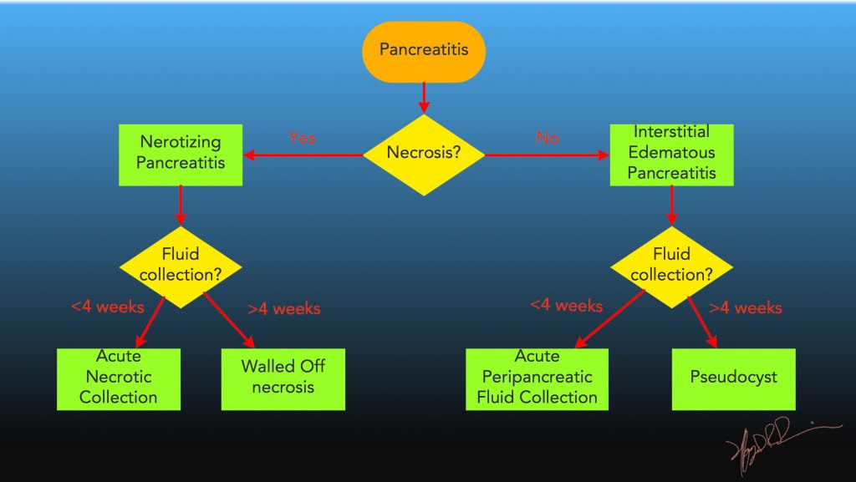

**Section 2: Diverticulitis/Infections colitis:**

**Video:**

https://www.youtube.com/watch?v=zeFHJ-4-w64  
<https://www.youtube.com/watch?v=FI8EN6p6Lac>

**Discussion Points:**

* Be able to identify the acute diverticulitis and features to suggest uncomplicated vs complicated
* What is the difference between Diverticulitis, Epiploic Appendagitis and Omental Infarct. Which is more common on the right and which more common on the left
* Which can cause fistula formation
* What actually bleeds more: Diverticulosis or diverticulitis
* Who gets C-Difficile and how does it affect the colon—imaging features.
* Who gets Typhlitis. What part of the colon is involved?

**Section 3: Appendicitis**:

**Videos:**

<https://www.youtube.com/watch?v=DBYg9B1Xg7s>  
<https://www.youtube.com/watch?v=0Ae3wxmwSn0>

**Radiopedia:** <https://radiopaedia.org/articles/appendicitis-2?lang=us>

**Radiology Assistant:** <https://radiologyassistant.nl/abdomen/acute-abdomen/appendicitis-and-mimics>

**Discussion Points:**

* What is the normal thickness of an appendix
* What is the imaging appearance of perforated (perforated/complicated) vs non-perforated appendicitis
* What are the 5 CT criteria used to distinguish perforated from non-perforated appendicitis?
* Name a few other DDx in patients presenting with RLQ pain.
* What is a Mucocele of the appendix

**Section 4: Pyelonephritis/ Ureterolithiasis**

**General Review Article StatPearls** <https://www.ncbi.nlm.nih.gov/books/NBK519537/>

**Video**:

<https://www.youtube.com/results?search_query=renal+emergencies+ct+scan>  
<https://www.youtube.com/watch?v=C0ILHQPvs6Y>

**Discussion Points:**

* Find the stone, discuss the associated findings including the degree of obstruction.
* What size kidney stone have a high likelihood of spontaneously passing and what size high likelihood of NOT passing
* Is contrast necessary to find an obstructing stone
* When is contrast beneficial in the setting of acute GU emergency
* Of the following stone compositions: match the associations
  + Calcium Oxalate
  + Struvite Stone
  + Uric Acid
  + Cysteine
  + Indinavir.
  + Most common;
  + associated with UTI;
  + Associated with low pH and diabetics
  + Associated with HIV and only one NOT seen on CT
  + Associated with congenital disorders.
* What is the most common organism in Pyelonephritis
* What Ct findings are associated with pyelonephritis.
* What Ct findings are suspicious for emphysematous pyelonephritis and what patient population is at risk
* How is Pyeonephrosis and Emphysematous Pyelitis different than pyelonephritis

**These sections below are informational. Of note: Sections 7 and 8 will be covered in more detail in the US block week**

**Section 5:** Duodenal Emergencies

https://www.youtube.com/watch?v=psJfRr_CADY

**Section 6:** Pelvic Inflammatory Disease

Usually begin with US however sometimes patient present with acute abdomen with clinical findings suggestive of other non gyn causes for pain. CT therefore may be ordered. This is a quick review and will be further discussed in Block 3 Ultrasound.

○ <https://www.youtube.com/watch?v=nnpASPO3WxQ>

**Section 7: Cholecystitis**

* **Video:**

[**https://www.youtube.com/watch?v=7aw-1x2Hf10&list=PLmLR8Tr01W7o_0z8G2OAXHDJdad-GBaCP&index=30**](https://www.youtube.com/watch?v=7aw-1x2Hf10&list=PLmLR8Tr01W7o_0z8G2OAXHDJdad-GBaCP&index=30)

<https://www.youtube.com/watch?v=9THRvgtNBLY&t=2565s>

**Summary approach to the Acute Abdomen:**

<https://radiologyassistant.nl/abdomen/acute-abdomen/practical-approach-to-acute-abdomen>