**Day 5: PROTOCOLS PACS AND PATIENTS**

**Objective:**

On this day the participant will be on-site and will be assigned to sit with a junior radiology resident to learn the process of evaluating a Drs order and the steps involved in establishing the protocol for the examination requested to best answer the clinical question. The student will gain insight on oral and enteric contrast as well as phases of examinations.

In addition, the participant will be given a quick tutorial on the current PACS system with the basic features an ordering provider would need to know to most efficiently use the system. The student will be provided with a few key contact numbers and file room coordinators' access to help guide them for future referrals.

The Lesson will conclude with direct patient care by observing a few patients being scanned from initial contact to completion of the process ready for radiologist review.

**PART 1 PROTOCOLS**

**Self-Learning Video/ Reference Files:**

**Abdomen and Pelvis Protocols:** [**https://www.youtube.com/watch?v=0cuGLnOEBzE**](https://www.youtube.com/watch?v=0cuGLnOEBzE)

**A practical Introduction to CT (review):** [**https://www.youtube.com/watch?v=VnpqylFYtqI**](https://www.youtube.com/watch?v=VnpqylFYtqI)

**CT contrast injection and protocols:** [**https://radiologyassistant.nl/more/ct-protocols/ct-contrast-injection-and-protocols#overview-of-ct-protocols**](https://radiologyassistant.nl/more/ct-protocols/ct-contrast-injection-and-protocols#overview-of-ct-protocols)

**Summary chart:**

**At the completion of the videos and review of teaching files the student should be able to:**

1. Have a broad understanding what organs and landmarks define CT Abdomen and CT Pelvis and when to order individually or collectively to answer the clinical question.
2. Have a broad understanding when to use IV contrast and when multiple phases are indicated to answer the clinical question.
3. Have a broad understanding when to order oral contrast either positive or negative to answer the clinical question.
4. Have a broad understanding when to order rectal contrast to answer the clinical question.
5. Be able to use Have a broad understanding what organs and landmarks define CT Abdomen and CT Pelvis and when to order

**PART 2 IMPACS Training**

**This will be directed by the junior radiology resident sample of AGFA IMPAX images are seen below.**

**At the completion of the PACS tutorial the student should be able to:**

1. Log into the PACS with his/her own username and password via <https://myapps.unch.unc.edu/Citrix/MyAppsWeb/>
2. Use the search bar to find a patient file by MRN or Accession number.
3. Be able to go to study list and find prior exams
4. Set up hanging protocols for multiple series (min 2x2) and apply toolbar tool to change as desired
5. Learn how to view one enlarged series and go back to the multiple series
6. Learn how to go to the thumbnails to drag the series to review
7. Learn how to look at virtual jacket to look at priors
8. Be able to click between prior and current exam
9. Be able to use the measurement tool for lesion size and HU tool
10. Be able to change the window and setting as needed
11. Be able to reset image when desired
12. Be able to link the series
13. Be able to use the Active Target when want to “pick a finding in the tangential views”
14. How to send chat message to the file room

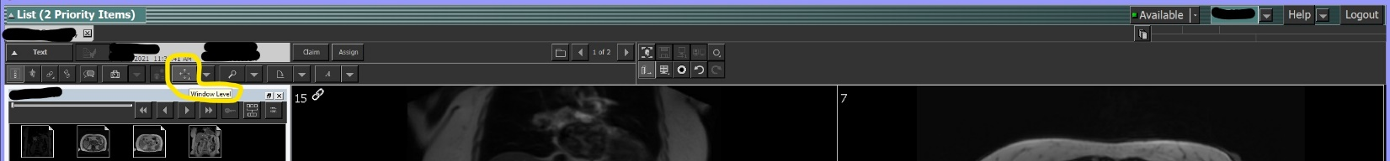

**PART 3 PATIENT EXAMINATION**

**The radiology resident will escort the medical student into a CT Tech workstation and introduce him/her to the technologist. The student will observe the process from patient arrival to the ending of the exam to the PACS for interpretation. At the completion of the PACS tutorial the student should be able to:**

1. Learn the Patient safety protocol
   1. Learn the questions asked regarding contrast allergy, renal function test and other safety measures taken prior to start of the exam.
2. Identify optimal patient position for exam of Abdomen and Pelvis
3. See the contrast loading and injection technique
4. See the final steps for completion of the examination

**PART 4: Q/A**

**Please provide the following prior to leaving the department for the day:**

1. Provide 3 protocol scenarios learned while protocoling cases with the resident (ex—How to order a study for hematuria) and the solution provided during today’s lesson.

2. Provide one patient safety lesson in the live patient CT scanning you learned today

Submit the q/a to [pina_finazzo@med.unc.edu](mailto:pina_finazzo@med.unc.edu) when completed.